Dynamic content Render

import logo from "./logo.svg";

import "./App.css";

import Greet from "./Greet";

import CoreImage from "../src/assets/react-core-concepts.png";

const reactDescriptions = ['Fundamental', 'Crucial', 'Core'];

function genRandomInt(max) {

  return Math.floor(Math.random() * (max + 1));

}

function Header() {

  return (

    <header>

      <img src={CoreImage} alt="Stylized atom" />

      <h1>React Essentials</h1>

      <p>

        {/* {1+1} */}

        {reactDescriptions[genRandomInt(2)]} React concepts you will need for almost any app you are

        going to build!

      </p>

    </header>

  );

}

function App() {

  const firstName = "Geetha";

  const lastName = "Samynathan";

  const isLoggedIn = false;

  return (

    // <div className="App">

    //   <h1> Welcome to React Session</h1>

    //   {/* conditional Rendering using ternary operator */}

    //   {isLoggedIn? (<h2> Hi {firstName} {lastName}</h2>):(<h2> Hi Guest</h2>)}

    //  <Greet/>

    // </div>

    <div>

      <Header />

      <main>

        <h2>Time to get started!</h2>

      </main>

    </div>

  );

}

export default App;

we can simplify the same with below code

import logo from "./logo.svg";

import "./App.css";

import Greet from "./Greet";

import CoreImage from "../src/assets/react-core-concepts.png";

const reactDescriptions = ['Fundamental', 'Crucial', 'Core'];

function genRandomInt(max) {

  return Math.floor(Math.random() * (max + 1));

}

function Header() {

  const description =reactDescriptions[genRandomInt(2)];

  return (

    <header>

      <img src={CoreImage} alt="Stylized atom" />

      <h1>React Essentials</h1>

      <p>

        {/* {1+1} */}

        {description} React concepts you will need for almost any app you are

        going to build!

      </p>

    </header>

  );

}

function App() {

  const firstName = "Geetha";

  const lastName = "Samynathan";

  const isLoggedIn = false;

  return (

    // <div className="App">

    //   <h1> Welcome to React Session</h1>

    //   {/* conditional Rendering using ternary operator */}

    //   {isLoggedIn? (<h2> Hi {firstName} {lastName}</h2>):(<h2> Hi Guest</h2>)}

    //  <Greet/>

    // </div>

    <div>

      <Header />

      <main>

        <h2>Time to get started!</h2>

      </main>

    </div>

  );

}

export default App;

Setting HTML Attributes Dynamically & Loading Image Files

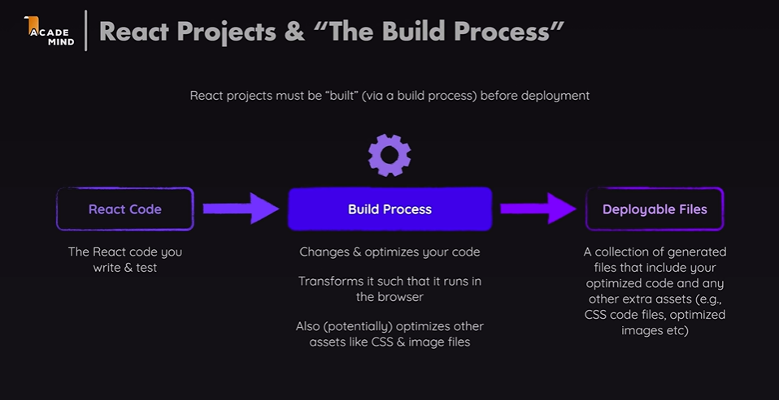

import logo from "./logo.svg";

import "./App.css";

import Greet from "./Greet";

import CoreImage from "../src/assets/react-core-concepts.png";

const reactDescriptions = ['Fundamental', 'Crucial', 'Core'];

function genRandomInt(max) {

  return Math.floor(Math.random() * (max + 1));

}

function Header() {

  const description =reactDescriptions[genRandomInt(2)];

  return (

    <header>

      <img src={CoreImage} alt="Stylized atom" />

      <h1>React Essentials</h1>

      <p>

        {/* {1+1} */}

        {description} React concepts you will need for almost any app you are

        going to build!

      </p>

    </header>

  );

}

function App() {

  const firstName = "Geetha";

  const lastName = "Samynathan";

  const isLoggedIn = false;

  return (

    // <div className="App">

    //   <h1> Welcome to React Session</h1>

    //   {/* conditional Rendering using ternary operator */}

    //   {isLoggedIn? (<h2> Hi {firstName} {lastName}</h2>):(<h2> Hi Guest</h2>)}

    //  <Greet/>

    // </div>

    <div>

      <Header />

      <main>

        <h2>Time to get started!</h2>

      </main>

    </div>

  );

}

export default App;

React Props

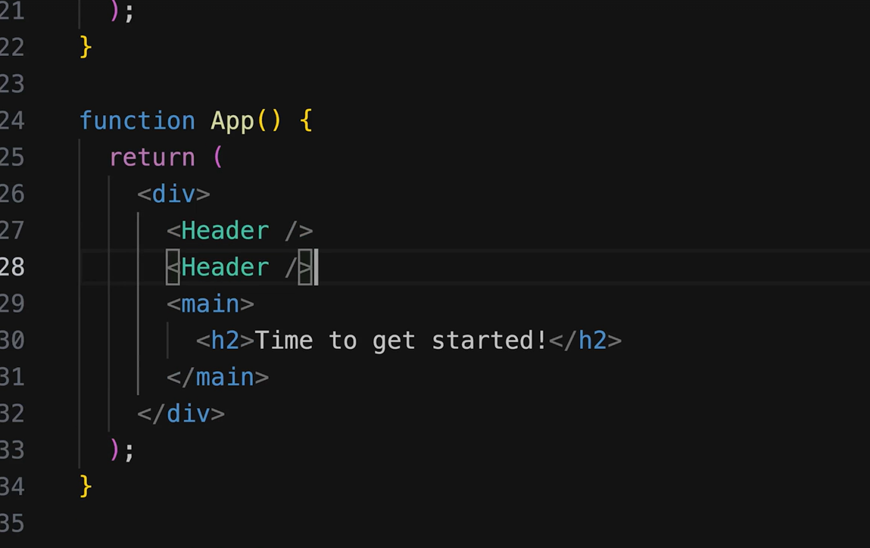

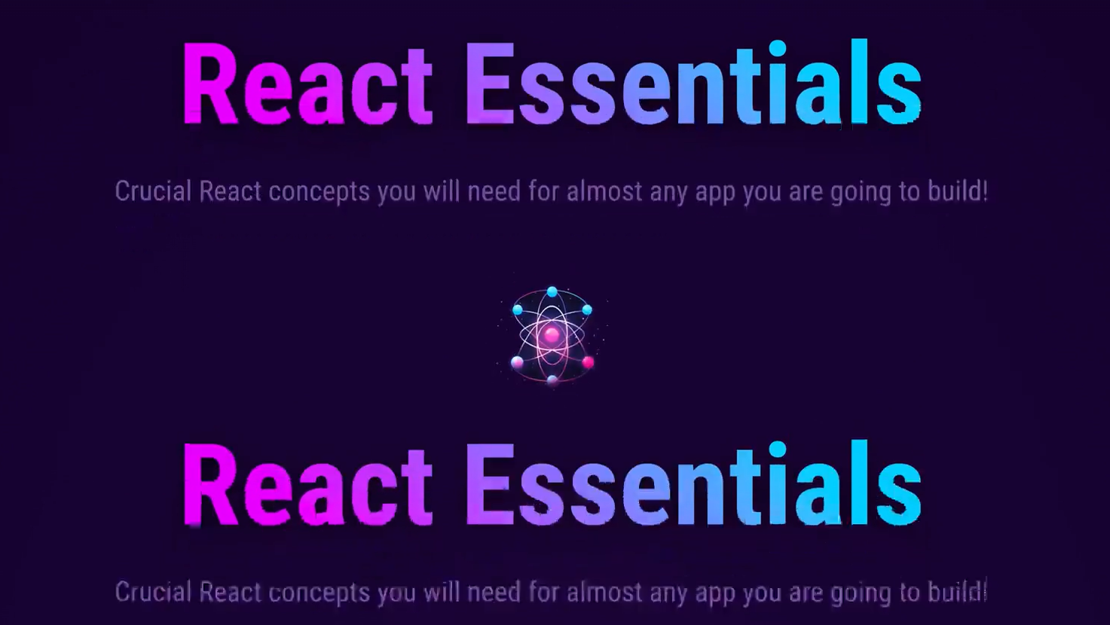



Components can be potentially reused

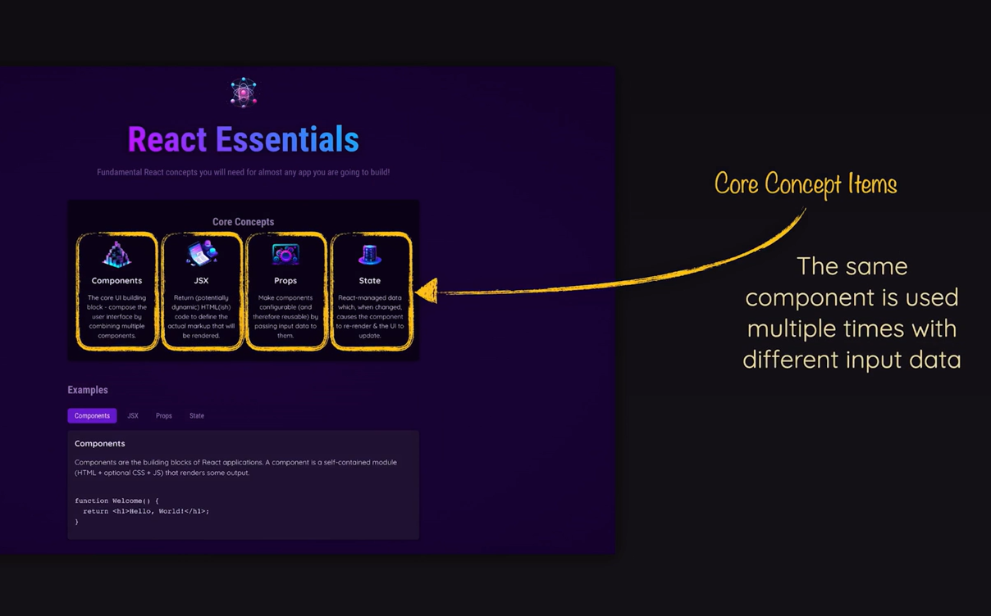



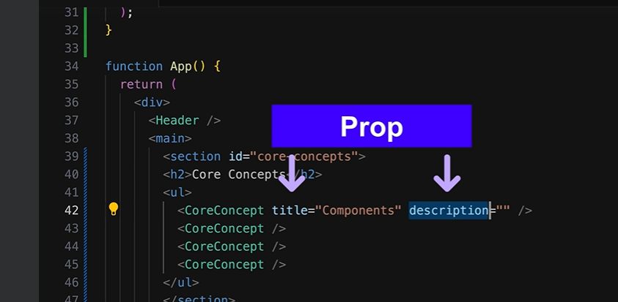

import logo from "./logo.svg";

import "./App.css";

import Greet from "./Greet";

import CoreImage from "../src/assets/react-core-concepts.png";

import ComponentsImage from "../src/assets/react-core-concepts.png";

const reactDescriptions = ['Fundamental', 'Crucial', 'Core'];

function genRandomInt(max) {

  return Math.floor(Math.random() * (max + 1));

}

function CoreConcepts(props)

{

  return(

    <>

    <li>

      <img src={props.img} alt='...'></img>

      <h3>{props.title}</h3>

      <p>{props.description}</p>

    </li>

    </>

  )

}

function Header() {

  const description =reactDescriptions[genRandomInt(2)];

  return (

    <header>

      <img src={CoreImage} alt="Stylized atom" />

      <h1>React Essentials</h1>

      <p>

        {/* {1+1} */}

        {description} React concepts you will need for almost any app you are

        going to build!

      </p>

    </header>

  );

}

function App() {

  const firstName = "Geetha";

  const lastName = "Samynathan";

  const isLoggedIn = false;

  return (

      <div>

      <Header />

      <main>

        <section id="core-concepts">

        <h2>Core Concepts</h2>

        <ul>

          <CoreConcepts title="Components"

          description="The core UI building b lock"

          img={CoreImage}

          />

          <CoreConcepts/>

          <CoreConcepts/>

        </ul>

        </section>

        <h2>Time to get started!</h2>

      </main>

    </div>

  );

}

export default App;

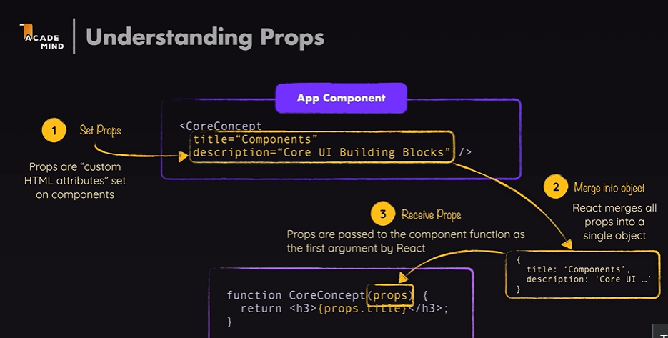

Output

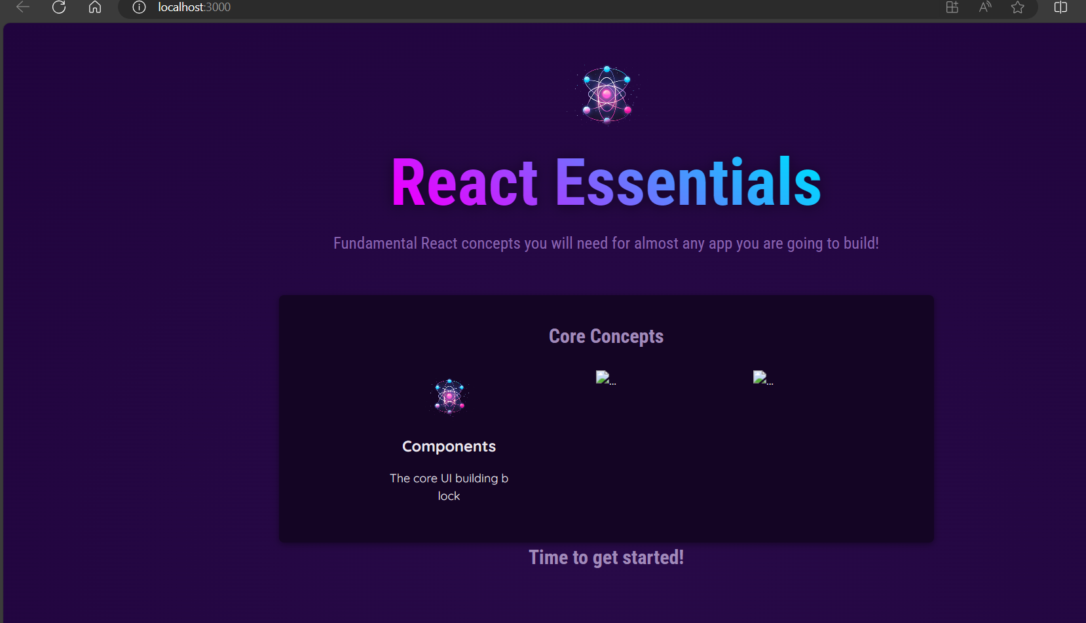

Alternative Props Syntaxes

Create new file with the name of data.js

import componentsImg from './assets/components.png';

import propsImg from './assets/config.png';

import jsxImg from './assets/jsx-ui.png';

import stateImg from './assets/state-mgmt.png';

export const CORE_CONCEPTS = [

{

image: componentsImg,

title: 'Components',

description:

'The core UI building block - compose the user interface by combining multiple components.',

},

{

image: jsxImg,

title: 'JSX',

description:

'Return (potentially dynamic) HTML(ish) code to define the actual markup that will be rendered.',

},

{

image: propsImg,

title: 'Props',

description:

'Make components configurable (and therefore reusable) by passing input data to them.',

},

{

image: stateImg,

title: 'State',

description:

'React-managed data which, when changed, causes the component to re-render & the UI to update.',

},

];

Create a new file CoreConcepts.jsx

function CoreConcepts(props)

{

  return(

    <>

    <li>

      <img src={props.img} alt='...'></img>

      <h3>{props.title}</h3>

      <p>{props.description}</p>

    </li>

    </>

  )

}

export default CoreConcepts;

App.jsx

import logo from "./logo.svg";

import { CORE_CONCEPTS } from "./data";

import "./App.css";

import Greet from "./Greet";

import CoreImage from "../src/assets/react-core-concepts.png";

import ComponentsImage from "../src/assets/react-core-concepts.png";

import CoreConcepts from "./CoreConcepts";

const reactDescriptions = ['Fundamental', 'Crucial', 'Core'];

function genRandomInt(max) {

  return Math.floor(Math.random() * (max + 1));

}

// function CoreConcepts(props)

// {

//   return(

//     <>

//     <li>

//       <img src={props.img} alt='...'></img>

//       <h3>{props.title}</h3>

//       <p>{props.description}</p>

//     </li>

//     </>

//   )

// }

function Header() {

  const description =reactDescriptions[genRandomInt(2)];

  return (

    <header>

      <img src={CoreImage} alt="Stylized atom" />

      <h1>React Essentials</h1>

      <p>

        {/* {1+1} */}

        {description} React concepts you will need for almost any app you are

        going to build!

      </p>

    </header>

  );

}

function App() {

  const firstName = "Geetha";

  const lastName = "Samynathan";

  const isLoggedIn = false;

  return (

      <div>

      <Header />

      <main>

        <section id="core-concepts">

        <h2>Core Concepts</h2>

        <ul>

          <CoreConcepts title={CORE_CONCEPTS[0].title}

          description={CORE_CONCEPTS[0].description}

          img={CORE_CONCEPTS[0].image}

          />

          <CoreConcepts title={CORE_CONCEPTS[1].title}

          description={CORE_CONCEPTS[1].description}

          img={CORE_CONCEPTS[1].image}

          />

           <CoreConcepts title={CORE_CONCEPTS[2].title}

          description={CORE_CONCEPTS[2].description}

          img={CORE_CONCEPTS[2].image}

          />

           <CoreConcepts title={CORE_CONCEPTS[3].title}

          description={CORE_CONCEPTS[3].description}

          img={CORE_CONCEPTS[3].image}

          />

        </ul>

        </section>

        <h2>Time to get started!</h2>

      </main>

    </div>

  );

}

export default App;

output

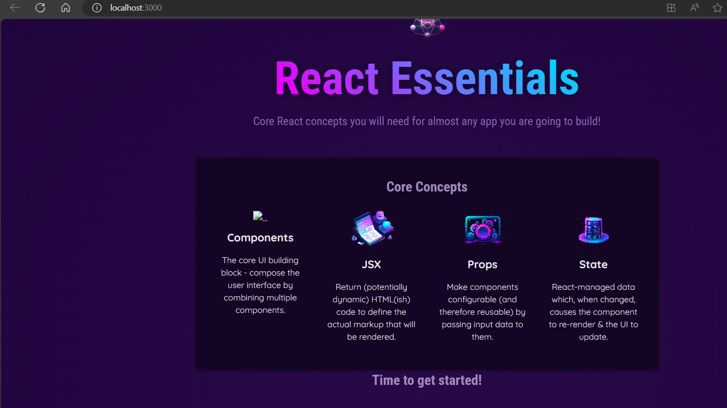

Event Handling Demo

Create a new component (file) TabButton.jsx

import React from "react";

export default function TabButton({children})

{

function handleClick(){

console.log('Hello World')

}

    return(

        <li>

            <button onClick={handleClick}>{children}</button>

        </li>

    )

}

App.js

import logo from "./logo.svg";

import { CORE_CONCEPTS } from "./data";

import "./App.css";

import Greet from "./Greet";

import CoreImage from "../src/assets/react-core-concepts.png";

import ComponentsImage from "../src/assets/react-core-concepts.png";

import CoreConcepts from "./CoreConcepts";

import TabButton from "./TabButton";

const reactDescriptions = ['Fundamental', 'Crucial', 'Core'];

function genRandomInt(max) {

  return Math.floor(Math.random() * (max + 1));

}

function Header() {

  const description =reactDescriptions[genRandomInt(2)];

  return (

    <header>

      <img src={CoreImage} alt="Stylized atom" />

      <h1>React Essentials</h1>

      <p>

        {/* {1+1} */}

        {description} React concepts you will need for almost any app you are

        going to build!

      </p>

    </header>

  );

}

function App() {

  const firstName = "Geetha";

  const lastName = "Samynathan";

  const isLoggedIn = false;

  return (

      <div>

      <Header />

      <main>

        <section id="core-concepts">

        <h2>Core Concepts</h2>

        <ul>

        <CoreConcepts title={CORE_CONCEPTS[0].title}

          description={CORE_CONCEPTS[0].description}

          img={CORE_CONCEPTS[0].image}

          />

          <CoreConcepts {...CORE_CONCEPTS[1]} />

          <CoreConcepts {...CORE_CONCEPTS[2]} />

          <CoreConcepts {...CORE_CONCEPTS[3]} />

        </ul>

        </section>

        <section id="examples">

          <h2>Examples</h2>

          <menu>

            <TabButton>Components</TabButton>

            <TabButton>JSX</TabButton>

            <TabButton>Props</TabButton>

            <TabButton>State</TabButton>

          </menu>

          Dynamic Content

        </section>

        <h2>Time to get started!</h2>

      </main>

    </div>

  );

}

export default App;

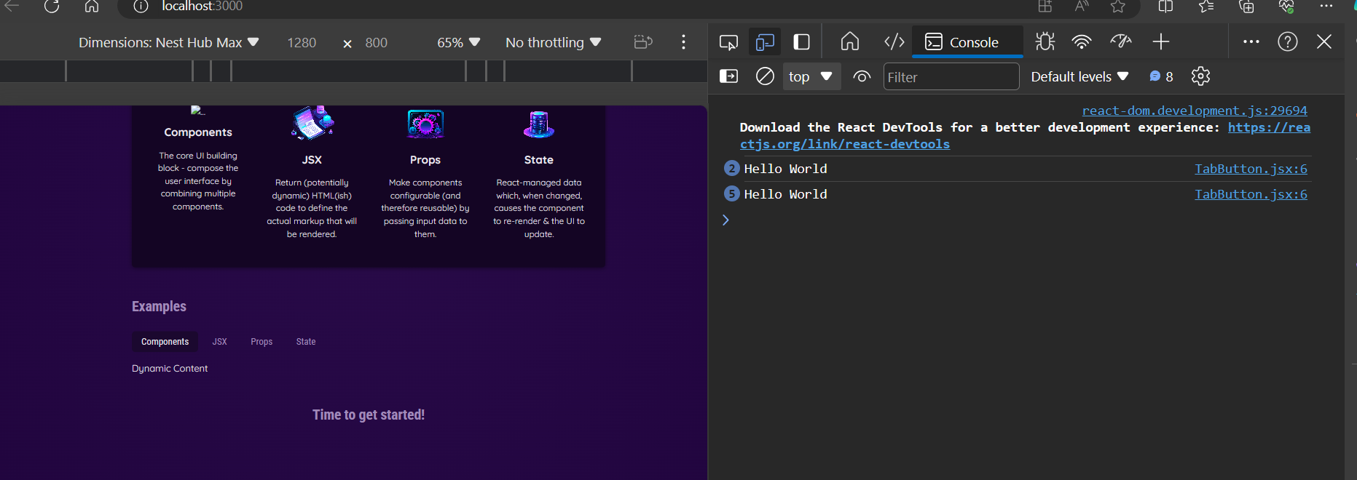

Another way to bind event from parent to child component

tabButton.jsx

import React from "react";

export default function TabButton({children,onSelect})

{

    return(

        <li>

            <button onClick={onSelect}>{children}</button>

        </li>

    )

}

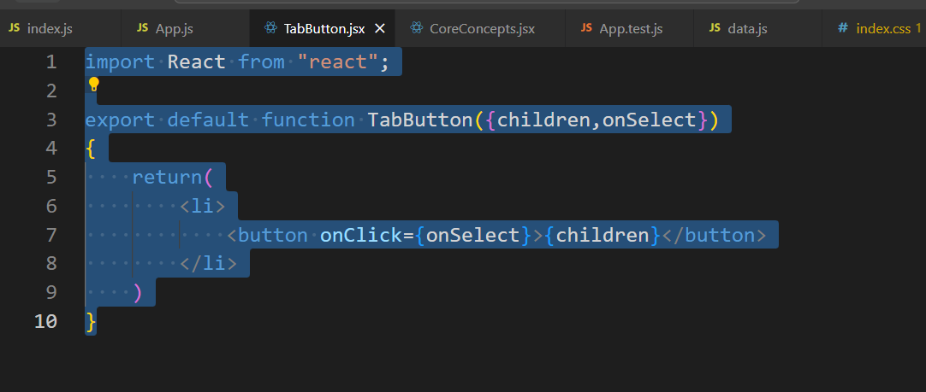

Property,can give any name

This is should not be changeable name

App.js

import logo from "./logo.svg";

import { CORE_CONCEPTS } from "./data";

import "./App.css";

import Greet from "./Greet";

import CoreImage from "../src/assets/react-core-concepts.png";

import ComponentsImage from "../src/assets/react-core-concepts.png";

import CoreConcepts from "./CoreConcepts";

import TabButton from "./TabButton";

const reactDescriptions = ['Fundamental', 'Crucial', 'Core'];

function handleSelect(){

  console.log('Hello World- selected')

}

function genRandomInt(max) {

  return Math.floor(Math.random() * (max + 1));

}

function Header() {

  const description =reactDescriptions[genRandomInt(2)];

  return (

    <header>

      <img src={CoreImage} alt="Stylized atom" />

      <h1>React Essentials</h1>

      <p>

        {/* {1+1} */}

        {description} React concepts you will need for almost any app you are

        going to build!

      </p>

    </header>

  );

}

function App() {

  const firstName = "Geetha";

  const lastName = "Samynathan";

  const isLoggedIn = false;

  return (

      <div>

      <Header />

      <main>

        <section id="core-concepts">

        <h2>Core Concepts</h2>

        <ul>

        <CoreConcepts title={CORE_CONCEPTS[0].title}

          description={CORE_CONCEPTS[0].description}

          img={CORE_CONCEPTS[0].image}

          />

          <CoreConcepts {...CORE_CONCEPTS[1]} />

          <CoreConcepts {...CORE_CONCEPTS[2]} />

          <CoreConcepts {...CORE_CONCEPTS[3]} />

        </ul>

        </section>

        <section id="examples">

          <h2>Examples</h2>

          <menu>

            <TabButton onSelect={handleSelect} >Components</TabButton>

            <TabButton onSelect={handleSelect}>JSX</TabButton>

            <TabButton onSelect={handleSelect}>Props</TabButton>

            <TabButton onSelect={handleSelect}>State</TabButton>

          </menu>

          Dynamic Content

        </section>

        <h2>Time to get started!</h2>

      </main>

    </div>

  );

}

export default App;

